IOT Poster and Case Study

Topic: Logistics

Name: Sohini Joarder | Roll No.: 20051108

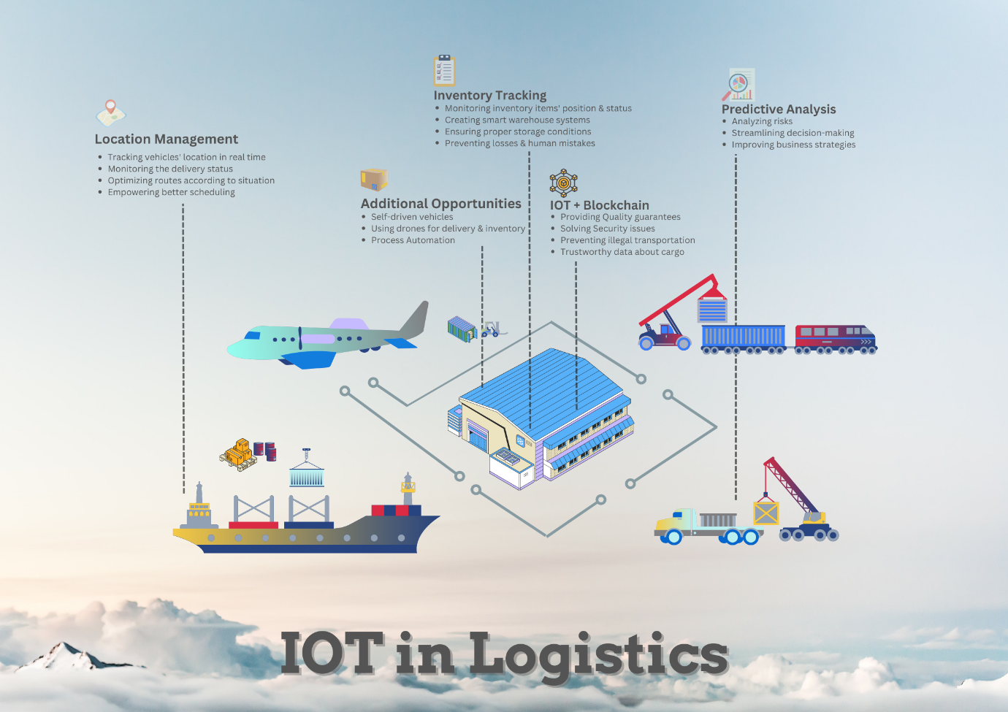

Case Study:



DHL

DHL is a global logistics company that provides a wide range of transportation and warehousing services to businesses and individuals. To improve its logistics operations, DHL has implemented a variety of IoT technologies.

One of DHL's major IoT initiatives is the deployment of smart sensors and devices throughout its supply chain. These sensors and devices provide real-time data on the location, condition, and status of goods as they move through the supply chain. This allows DHL to track shipments more accurately, reduce the risk of damage or loss, and improve the overall efficiency of its logistics operations.

DHL has also implemented IoT-enabled tracking and tracing systems. These systems use advanced analytics and machine learning algorithms to analyse data from multiple sources, including sensors, GPS, and weather forecasts, to provide real-time visibility into the status of shipments. This allows DHL to proactively identify potential delays or disruptions and take corrective action before they become problems.

Another major IoT initiative at DHL is the use of autonomous vehicles and drones. DHL has deployed a variety of autonomous vehicles, including drones and self-driving trucks, to improve the speed and efficiency of its logistics operations. These vehicles use IoT technologies to communicate with each other and with DHL's logistics systems, allowing for more efficient routing and delivery.

The implementation of IoT technologies has yielded significant benefits for DHL. Smart sensors and tracking systems have improved supply chain visibility, reduced the risk of lost or damaged shipments, and improved the overall efficiency of logistics operations. Autonomous vehicles and drones have also helped DHL improve the speed and accuracy of its deliveries, while reducing costs and carbon emissions.

Overall, DHL's implementation of IoT technologies in its logistics operations demonstrates the potential for IoT to transform the logistics industry by improving efficiency, reducing costs, and enhancing customer service.